MatRev Project

Document Initiating the Project (DIP)

## Overview

|  |  |  |  |  |  |  |  |  |  |
| --- | --- | --- | --- | --- | --- | --- | --- | --- | --- |
| **ID** | **Changes in Document** | **Responsible** | **Date of Change** | **Added Elements** | **Description** | **Pg.** | **Acc.** | **Acc. by** | **Comments** |
| 1 | Project Brief | Team | 17/03/2017 | Introduction | Added the general Introduction about the Project | 2 | Yes | K. Frączkowski |  |
| Purpose | Added the actual Purpose of the Project | 2 |
| Background | Added the Background about why the project has been started | 2 |
| Project Definition | Added the Definition of the Project | 2 |
| Project Scope | Added the scope and major dependencies of the Project | 2 |
| Outline project deliverables and desired outcomes | Added the products and the outcomes of the project | 2-3 |
| Constraints | Added the constraints for the initiation of the Project | 3 |
| Interfaces | Added the elements interfacing with the Project | 3 |
| Outline business case | Added the main stakeholders and the end users of the Product | 3 |
| Customer’s quality expectations | Added the expectations to the quality of the product | 3 |
| Acceptance criteria | Added the functional and non-functional aspects for Acceptance of the Product | 3 |
| Outline project plan | Added the estimated budget and product delivery dates | 4 |
| Risks | Added the possible risks emerging during the project | 5 |
| 2 | Document Initiation of Project | Team | 25/03/2017 | Technical Traits | Added supported android versions and permissions | 4 | Yes | K. Frączkowski |  |
| Actual Key Delivery Dates | Modified Outline Project Plan | 4 |
| WBS | Added the link to external WBS file | 4 |
| Milestones | Added the most important achievement for the first sprint | 5 |
| Monitoring | Added the source of monitoring the project | 5 |
| Risk Owners | Added who is responsible for risks | 5 |
| Justification for the selection of Priorities | Added description of why we selected some priorities | 7 |
| 3 | General additions | Team | 27/03/2017 | Risk Table | Modified Risk Table by adding the owner and status columns | 5 | Yes | K. Frączkowski |  |
| 4 | Changes in the Sprint 1 Duration | Team | 03/04/2017 | None | Due to the delay caused during the week, we have increased the deadline for the Sprint 1. | 5 | Yes | K. Frączkowski | <MatRev.mpp>  <MatRev.pdf> |
| Update of the Sprint 1 Plan | Due to the increased Sprint duration, we changed the duration for each task to be carried out. | 6 |
| Addition of Sprint 2 Plan | Sprint 2 Plan, New column | Added the tasks to be done in the Sprint 2. And Added a “Comments” column in the overview. | 6 |
| Addition of Communication Plan | Communication Plan | Added the communication plan to the Document of Project Initiation | 8 |
| 5 | Addition of a new functionality | Team and Company Owner | 09/04/2017 | Password addition, new functionality | Added a new point to the functionalities in the Acceptance Criteria | 5 | Yes | K. Frączkowski |  |
| 6 | Addition of Reaction | Team | 10/04/2017 | Reaction, New column | Added reaction column to the risk table | 7 | Yes | K. Frączkowski |  |
| Addition of Reaction Description | Reaction Description, New column | Added “Reaction Description” column to the risk table |
| Addition of Task/Cost | Task/Cost, New column | Added “Task/Cost” column to the risk table |
| Addition of Risk Probability/Influence table | Risk Probability/Influence Table | Added a new table to the document, Risk Probability/Influence | 9 |
| Addition of Impact Table | Impact Table | Added a new table to the document, Impact Table |
| Addition of Risk Profile | Risk Profile Table | Added a new table to the document, Risk Profile Table |
| 7 | Sprint Review Meeting | Team | 19/04/2017 | <Matrev.pptx>  [1st Sprint Review Meeting Record.docx](1st%20Sprint%20Review%20Meeting%20Record.docx) | Added hyperlinks to the presentation and the report created for the Sprint Review Meeting. | 7 | Yes | K. Frączkowski | Comments included in the Sprint Review Meeting Report |

## Introduction

This project brief is directed towards the use of the staff of the company which is interested in this project. This project will aim towards producing mobile application for revising theoretical material connected with machine operating.

## Purpose

Main purpose of “MatRev” is to help the students who are taking courses of machine operators to revise material and used as reference later and decrease amount of accidents by 10%.

## Background

The company “H.M.K.” is doing courses for operators of multiple machines. Due to low education level among the students there is a problem of revising big amount of text. In order to help them to prepare for final exam this application is created.

## Project definition

**Project objectives are:**

* To improve theoretical knowledge of students
* To level up the percentage of passed students
* To increase safety level for operators
* To decrease number of accidents
* To increase the machines’ lifetime

## Project scope

Scope is developing a mobile application for Android devices for objectives mentioned before.

**Main dependencies:**

* Deliver the final product in time

**Main independencies:**

* Verifying knowledge provided by application

## Outline project deliverables and/or desired outcomes

**Deliverables are:**

* Application
* User guide
* Project documentation

**Exclusions:**

* Training of end-users
* Acquiring of new hardware

## Constraints

* In the beginning, we don’t have enough information on the subject, so we need to collect it from reliable source
* Information need to be up-to-date
* Application should be done by the end of semester

## Interfaces

Application will interface with clients’ company and with customers.

## Outline business case

This application will be used mainly by the students who are taking the courses preparing them for operating machines, another usage will be to prepare them for the final exam.

The profit will increase with the increase number of happy customers. This application will help the users to answer ambiguous questions.

## Customers’ quality expectations

The information provided should be useful, reliable and up-to-date.

The application should be easy to use and intuitive.

The customer quality can be measured by the rate of students who have covered the available materials and passed the final exam.

## Acceptance Criteria

**Functional:**

* Ability to filter the information
* Helpful presentation of information for example, flashcards.
* Smart organization of provided materials
* Touch enabled
* Adaptable to different resolutions
* Password Access for the courses
* Password validation period

**Non-functional:**

* Simple design
* Quick response time

## Technical Traits

**Android Supported Versions:**

* Ice Cream Sandwich (4.0 - 4.0.4)
* Jelly Bean (4.1 - 4.3.1)
* Kit Kat (4.4 - 4.4.4)
* Lollipop (5.0 - 5.1.1)
* Marshmallow (6.0 - 6.0.1)
* Nougat (7.0 - 7.1.1)

**Supported Devices:** All Android supported platforms.

**Permissions:** Some useful Android permissions

## Outline Project Plan

**Elements of cost:**

* Android market registration fee: 100 zł
* Part-time Personnel: 2000 zł / month
* Stationary and printing: 10 zł

**Key delivery dates:**

* Planning
* Installation of requiring tools
* Gathering information
* Training people working on this project
* Implementation (2 weeks each)
  + Sprint 1 (10/04/2017)
  + Sprint 2 (19/04/2017)
  + Sprint 3 (30/04/2017)
  + Sprint 4 (15/05/2017)
  + Sprint 5 (29/05/2017)
  + Sprint 6 (12/06/2017)
* Testing (19/06/2017)
* Deployment (19/06/2017)
* Review (19/06/2017)
* Keeping support

(**Note**: All dates are subject to change)

**Resources:**

Personnel, Initial cost

## WBS

<MatRev.pdf>

## COCOMO II

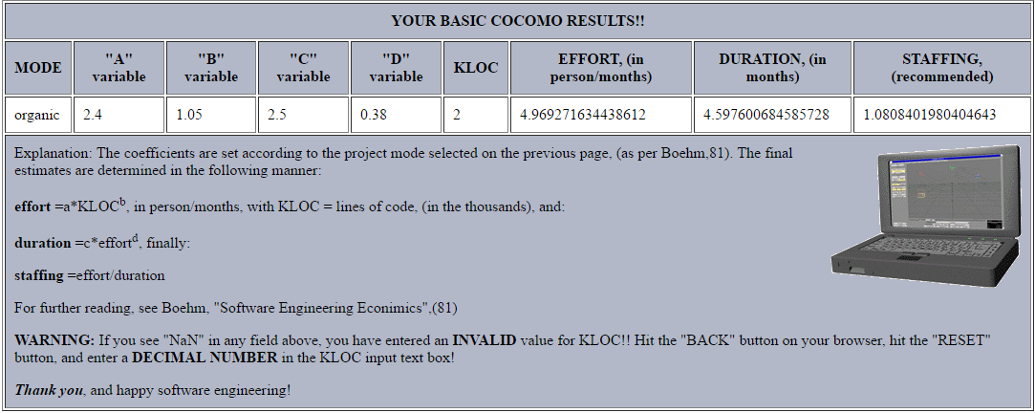

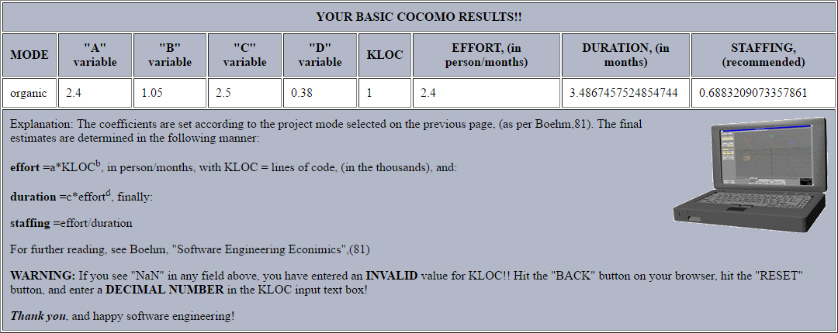

Comment… about why we took 2 models, coz the one with 2k lines has 4 months and the other one no. ESTIMATION

## Milestones: First Sprint

* Designing (30/03/2017)
  + Designing Color Schemes (22/03/2017)
  + Designing Screens (30/03/2017)
* Mockups (03/04/2017)

## Monitoring

The project is being monitored with the use of MS Project.

<MatRev.mpp>

## Sprint Review Meetings

### Meeting 1 (19/04/2017)

* <Matrev.pptx>
* [1st Sprint Review Meeting Record.docx](1st%20Sprint%20Review%20Meeting%20Record.docx)

## Risks

* Information inconsistencies
* Outdated information
* Unreliable sources
* Lack of required skills
* Impact on eyesight
* Inaccurate planning
* Stress
* Unhandled exceptions in the application

**Risk Owner:** Paulina Binas

**Partial Risk Owners:** Arseny Mansyrev, Rupali Sharma, Tenzin Choewang

|  |  |  |  |  |  |  |  |  |  |  |
| --- | --- | --- | --- | --- | --- | --- | --- | --- | --- | --- |
| **Number** | **Task name** | **Category** | **Risk** | **Owner** | **Status** | **Consequences** | **Risk Description** | **Reaction** | **Reaction Description** | **Task/Cost** |
| 1 | Information inconsistencies | T | 6 | Paulina Binas | Inactive | Impact on the usage of machines | Information provided is misinterpreted | Reduce | Try to reduce the information inconsistencies by paying more attention in the designing phase. | Misinterpretation on information |
| 2 | Outdated information | T | 3 | Paulina Binas | Inactive | Negligence of updated information | Information provided is not up-to-date, and hence, unreliable | Update | Try to constantly refresh available information basing on the sources. | Expired information, unreliable |
| 3 | Unreliable sources | T | 7 | Paulina Binas | Inactive | Incorrect usage of machines, leading to damages | Information provided is not trust-worthy, and hence, leading to mistakes | Refresh | Try to consult experts or almost reliable sources. | ~ 1000 zł |
| 4 | Lack of required skills | O | 6 | Paulina Binas | Active | Incompleteness and unreliability of the application | Inability to implement the functionalities | Reduce | Train better the crew to improve their skills | Application failure |
| 5 | Impact on eyesight | I | 54 | Paulina Binas | Active | Injuries at workplace | Eyesight getting worse | Medical advice | Consult a Doctor to improve the eyesight or take appropriate measures | Medical facility |
| 6 | Inaccurate planning | T | 42 | Paulina Binas | Active | Not finishing project in time | Exceeding the planned timeline | Reduce | Pay more attention while the planning process and avoid mistakes | Project deadline extension |
| 7 | Stress | I | 36 | Paulina Binas | Active | Mistakes in implementation | Pressure due to high expectations | Rest | Increase resting hours | Affected application quality |
| 8 | Unhandled exceptions in the application | T | 3 | Paulina Binas | Inactive | Failure of application | Fatal errors due to incomplete testing | Reduce | Better implementation and more testing | Fatal errors and application failure |

|  |  |  |
| --- | --- | --- |
| **Category** | **Weight** | **R** |
| Technical (T) | 5 | 61 |
| Organizational (O) | 1 | 6 |
| Inside (I) | 2 | 90 |

**Weight** = Number of all the risks in category

**Risk formula** -> **R** = S * E * P, where

S – potential loss

Values:

* 100 – huge disaster with many lethal casualties and over 25 million PLN loss
* 40 – disaster with a few lethal casualties and over 5 million PLN loss
* 15 – very big loss with one lethal casualty and over 500k PLN loss
* 7 – big loss with severely injured casualty and over 25k PLN loss
* 3 – regular loss with injured casualty and over 5k PLN loss
* 1 – small loss with very slight injury and less than 5k PLN loss

E – exposure to the risk

Values:

* 10 – constant exposure
* 6 – everyday exposure
* 3 – once a week exposure
* 2 – once a month exposure
* 1 – a few times per year exposure
* 0.5 – once a year exposure

P – probability of occurrence

Values:

* 10 – 50%
* 6 – 10%
* 3 – 1%
* 1 – 0.1%
* 0.5 – 0.01%
* 0.2 – 0.001%
* 0.1 – 0.0001%

## Impact Table

|  |  |  |  |  |  |
| --- | --- | --- | --- | --- | --- |
| **Probability** |  |  |  |  |  |
| **0.1** | 0.01 | 0.03 | 0.05 | 0.07 | 0.09 |
| **0.3** | 0.03 | 0.09 | 0.15 | 0.21 | 0.27 |
| **0.5** | 0.05 | 0.15 | 0.25 | 0.35 | 0.45 |
| **0.7** | 0.07 | 0.21 | 0.35 | 0.49 | 0.63 |
| **0.9** | 0.09 | 0.27 | 0.45 | 0.63 | 0.81 |
| **Influence** | **0.1** | **0.3** | **0.5** | **0.7** | **0.9** |

## Risk Probability/Influence

|  |  |  |  |  |  |  |  |  |  |  |
| --- | --- | --- | --- | --- | --- | --- | --- | --- | --- | --- |
| **Number** | **Risk name** | **Probability** | **Product** | | | | | | | |
| 1 | Information inconsistencies | 0.5 | 0.05 |  |  |  |  |  |  |  |
| 2 | Outdated information | 0.3 |  | 0.03 |  |  |  |  |  |  |
| 3 | Unreliable sources | 0.5 |  |  | 0.25 |  |  |  |  |  |
| 4 | Lack of required skills | 0.3 |  |  |  | 0.03 |  |  |  |  |
| 5 | Impact on eyesight | 0.5 |  |  |  |  | 0.15 |  |  |  |
| 6 | Inaccurate planning | 0.5 |  |  |  |  |  | 0.25 |  |  |
| 7 | Stress | 0.5 |  |  |  |  |  |  | 0.05 |  |
| 8 | Unhandled exceptions in the application | 0.3 |  |  |  |  |  |  |  | 0.03 |
| **Influence** | | | 0.1 | 0.1 | 0.5 | 0.1 | 0.3 | 0.5 | 0.1 | 0.1 |
| **Number** | | | 1 | 2 | 3 | 4 | 5 | 6 | 7 | 8 |

## Risk Profile

|  |  |  |  |  |  |
| --- | --- | --- | --- | --- | --- |
| **Probability** |  |  |  |  |  |
| **0.1** |  |  |  |  |  |
| **0.3** | 2, 4, 8 |  |  |  |  |
| **0.5** | 1, 7 | 5 | 3, 6 |  |  |
| **0.7** |  |  |  |  |  |
| **0.9** |  |  |  |  |  |
| **Influence** | **0.1** | **0.3** | **0.5** | **0.7** | **0.9** |

**Note:** The most critical risks in this project are “Unreliable Sources” and “Inaccurate Planning”.

**Comments:** The prevention methods for the risks mentioned are trying to consult experts or almost reliable sources to reduce unreliability of sources and pay more attention while the planning process to avoid mistakes and make the planning more accurate.

## Justification for the Selection of Priorities

The first Sprint has been designed taking in consideration the very basic tasks of the project. For example, the color schemes and the designing are necessary for the mockups.

## Communication Plan

**Shareholders:** Team, Company owner, Product owner

**Team:**

Paulina Binas: 785473283

Rupali Sharma: 536393925

Arseny Mansyrev: 732042160

Tenzin Choewang: 518052927

**Product Owner**

Kazimierz Frączkowski: [franczkowski.kazimierz@pwr.edu.pl](mailto:franczkowski.kazimierz@pwr.edu.pl)

**Company Owner**

Mariusz Rudkiewicz: 602250762

|  |  |  |  |  |  |  |  |
| --- | --- | --- | --- | --- | --- | --- | --- |
| **ID** | **Who?** | **With Whom?** | **Information type** | **Frequency** | **Information Location** | **Information Goal** | **Information Form** |
| 1 | Team | Company owner | Notification about the scrum meeting | After the end of each sprint | In Document of Project Initiation | Scrum meeting | Verbal and Email communication |
| 2 | Team | Product Owner | Sprint discussions | Every Monday | In Document of Project Initiation, Project monitoring document | Weekly progress tracking meeting | Face to face meeting, Verbal and Email communication |
| 3 | Team | Team | Working | Every Saturday | In the implementation files | Product progress tracking meeting | Face to face meeting, Verbal communication, Social media |

**Authors:**

Paulina Binas, 220641

Rupali Sharma, 223212

Tenzin Choewang, 218890

Arseny Mansyrev, 234639